# Proposed Research Activities

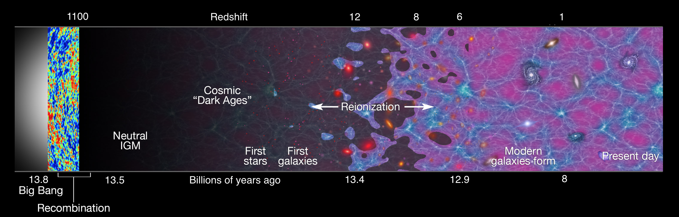

Fig. 1 – **The Cosmic Dawn Institute (CDI) will study a heretofore unexplored era in our Universe’s history, the *Cosmic “Dark Ages”* and *Reionization*.** The figure shows a timeline of our Universe’s history, with time measured backwards from the present day labeled on the bottom axis. At early times (far left), the Universe’s properties have been well mapped out by CMB experiments. At the present day (far right), traditional astronomical observations have provided a wealth of measurements. However, the Cosmic Dawn, when the first stars and galaxies formed, are a new frontier whose astrophysics the CDI will help to unlock. From Robertson et al. (2010).

**I. Introduction: The crucial epoch of the Cosmic Dawn**

One of cosmology’s primary goals is to understand how the complex, beautiful astronomical structures surrounding us today formed from simple primordial physics. In the last few decades, astrophysicists have established a framework for this story: tiny perturbations generated by the Big Bang slowly coalesce under their mutual gravity to form increasingly dense structures and eventually complicated galaxies. However, the details of precisely how these galaxies grow within dark clumps of matter into the first luminous objects – thereby inducing the **Cosmic Dawn** – remain unknown, representing a key missing piece in our cosmic timeline (see Fig.1).

The Cosmic Dawn also fascinates astronomers because it holds so much information about the constituents of our Universe (e.g., Loeb & Furlanetto 2013): its large-scale properties (such as the distribution of matter) drive the formation of the first stars and galaxies, which in turn ionize the hydrogen atoms found throughout the intergalactic medium (IGM), a process known as *reionization*. Indeed, the Cosmic Dawn was cited as one of three top science priorities in the 2010 *New Worlds, New Horizons of Astronomy and Astrophysics Decadal Survey* conducted across the entire astronomical community. **The University of California Cosmic Dawn Institute (CDI) will catapult UC to worldwide leadership in the study of this period.**

While theorists have long studied the Cosmic Dawn, it is only now coming into focus observationally. There are two basic approaches to this era. The first uses traditional astronomical observations of luminous sources with the *Hubble Space Telescope* and facilities like UC’s *Keck Observatory*. These observations are challenging, because the galaxies’ optical light is shifted into the near-infrared and partly absorbed by intervening material, but in the past few years astronomers have assembled relatively large samples of galaxies at the tail end of this era (e.g., Stark et al. 2010, Robertson et al. 2010, 2013, 2015, Treu et al. 2013, Oesch et al. 2014, Bouwens et al. 2015, Atek et al. 2015). The alternative is to observe properties of the IGM, which contains 95% of the matter at this time. Measurements of the cosmic microwave background (CMB) and absorption toward luminous sources are mostly consistent with inferences from the galaxy samples (Bolton et al. 2012, Hinshaw et al. 2013, Becker et al. 2015, Planck Collaboration 2016).

However, these probes are indirect and contain only a small fraction of the information available from the IGM. Dedicated low-frequency radio telescopes have the unique opportunity to unlock the rest of this information

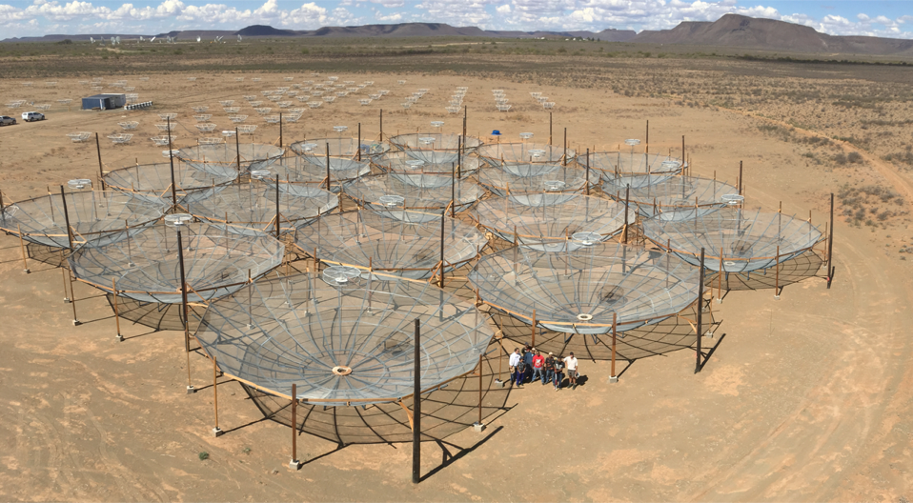 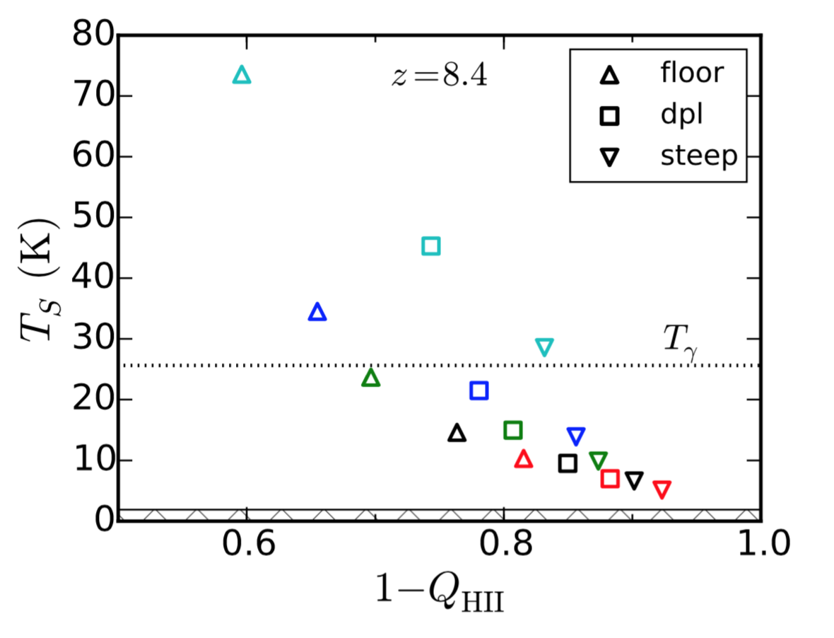

Fig. 2 – **The CDI places UC at the forefront of the emerging field of the Cosmic Dawn by linking modeling and analysis of that era with revolutionary observations**, such as those to be made with the UC-led Hydrogen Epoch of Reionization Array (HERA). Pictured at *left* are the first 19 antennae of that array in South Africa’s Karoo Desert, each with a diameter of 14 m. The final array, which will consist of 240 radio dishes, will provide the first direct observations of the reionization process over the next few years. At *right*, we show two of HERA’s observables in a set of models of early galaxies about 600 Myr after the Big Bang (symbols; here we vary only the star formation efficiency inside galaxies and the chemical composition of those galaxies). The abscissa corresponds to the fraction of the IGM that is neutral at that time, while the ordinate shows the spin temperature of the gas. Current PAPER observations disfavor the model at bottom right (Greig et al. 2016). **The CDI will analyze a wide variety of observational probes through a unified framework of galaxy formation in order to optimize constraints on the Cosmic Dawn.** From Mirocha et al. (2016)

by directly measuring the IGM’s properties. The neutral hydrogen that comprises the bulk of the IGM emits faint radio waves via the “spin-flip” transition of neutral hydrogen as such a probe. This transition, with a rest wavelength of 21 cm, is driven by magnetic interactions between the proton and the electron and is extraordinarily weak – but the enormous quantity of hydrogen in the Universe nonetheless renders it visible. With this line, such telescopes can trace the distribution of neutral hydrogen in three dimensions. Since the first galaxies determine the neutral hydrogen content of the IGM, 21-cm mapping provides an incisive probe of both the IGM and luminous sources (Furlanetto et al. 2006, Morales & Wyithe 2010, Pritchard & Loeb 2012).

Over the past several years, a suite of radio interferometers have targeted this signal, including the LOw Frequency ARray (LOFAR; Mellema et al. 2013), the Murchison Widefield Array (Bowman et al. 2013, Tingay et al. 2013, Dillon et al. 2015) and the Giant Metrewave Radio Telescope Epoch of Reionization experiment (GMRT-EoR; Paciga et al. 2013). Importantly, UC Berkeley leads the Donald C. Backer Precision Array for Probing the Epoch of Reionization (PAPER; Parsons et al. 2010). In spirit, these telescopes are similar to Cosmic Microwave Background (CMB) experiments, which revolutionized cosmology by mapping the earliest epochs of cosmic evolution. With 21-cm cosmology, we have the opportunity to do the same for the Cosmic Dawn.

PAPER has pioneered novel data analysis techniques (Parsons et al. 2012a,b, Liu et al. 2014,a,b) that have led to the most stringent upper limits on the cosmological signal, already placing severe constraints on so-called ‘cold-reionization’ theories (Ali et al. 2015, Pober et al. 2015). In conjunction with work completed under our MRPI planning grant, the NSF has now approved funding for the next-generation 21-cm telescopesuccessor to PAPER, the UC-led Hydrogen Epoch of Reionization Array (HERA; DeBoer et al. 2016; see Fig. 2). This instrument will have both an enormous collecting area and an extraordinarily rapid survey speed – both essential for surveying the large cosmic volumes necessary for these measurements. A prototype instrument is already observing in South Africa, and expansion to a 240-dish array will begin later this year. Forecasts suggest that HERA will make a definitive characterization of the 21-cm signal from reionization by 2020 (Pober et al. 2014).

Interpreting the 21-cm signal, however, is extremely difficult: these are complex statistical measurements that depend on a host of astrophysical processes, so their interpretation will require extensive modeling and analysis, well beyond that funded by the NSF. Moreover, a complete understanding of this era requires combining the 21-cm data with complementary observations of the galaxies themselves and other astrophysical probes. These techniques will also improve dramatically by the end of this decade, particularly with the launch of the James Webb Space Telescope (JWST) in late 2018 [SPHEREx???]. **The CDI will develop tools to (1) provide a unified theoretical interpretation of galaxy, 21-cm, and other measurements; (2) develop detailed cross-correlation techniques between these disparate probes; and (3) design next-generation experiments to ensure UC’s place at the forefront of this emerging field.**

The CDI is a **fundamentally system-wide project**, uniting expertise in four distinct efforts (galaxy theory, reionization theory, 21-cm observations, and galaxy observations). UC is uniquely positioned to fill this niche, with worldwide leaders in all of these areas. PI Steven Furlanetto (UCLA) and Co-PI Peng Oh (UCSB) pioneered a theoretical understanding of reionization and the statistics of 21-cm telescopes. Co-PI Aaron Parsons (UCB) leads both the PAPER and HERA experiments. Co-PIs Brant Robertson (UCSC) and Asantha Cooray (UCI) have led the interpretation of galaxy observations during the reionization era.

**II. Research Program**

Next, we will articulate a research program that will enable the necessary advances and optimally position UC for the future (see Fig. 3). Our three conceptual themes each necessitate cross-campus collaboration.

***A. The data-model connection***: HERA will precisely characterize the statistical properties of the 21-cm signal, primarily through its *power spectrum* (or the fluctuation amplitude as a function of smoothing scale). Connecting these measurements to the properties of the first generations of galaxies and other luminous sources, as well as the constituents of the IGM, requires its interpretation through theoretical models at a much deeper level than currently available (see Fig. 2). For example, the most sophisticated analysis tool available today (Greig & Mesinger 2015) cannot accommodate our “best guess” models for galaxies during the reionization era (shown in Fig. 2; Sun & Furlanetto 2016, Mirocha et al. 2016). **This theme therefore focuses on developing more sophisticated statistical analysis tools as well as more effective models of both reionization and the galaxy population.**

(1) Co-I Liu, an expert in 21-cm data analysis, will work with Co-PI Oh, an expert in the reionization signal and its statistics, to develop fast, efficient analysis tools that optimize the extraction of meaningful astrophysical parameters for rapid application to HERA data (e.g., Lin et al. 2016).

(2) PI Furlanetto has recently constructed a set of simple models of galaxy formation during the Cosmic Dawn, constrained by existing galaxy observations (Sun & Furlanetto 2016, Mirocha et al. 2016). But these observations have not yet probed the faintest galaxies, which both dominate the star formation budget and are most likely to host exotic processes. Together with Co-PI Robertson, Furlanetto will develop a comprehensive semi-analytic framework to model these galaxies, validated by Robertson’s numerical simulations.

(3) Co-PI Oh will develop models of the circumgalactic medium of proto-galaxies, to better understand and place theoretical priors on the most uncertain parameters in reionization: the escape fraction of ionizing and Ly-alpha photons. In conjunction with Co-PI Robertson, he will devise multi-wavelength observational tests.

(4) In collaboration with the entire team, Furlanetto will use the theoretical model to develop a flexible statistical framework for interpreting 21-cm data *in combination* with complementary astrophysical measurements (especially galaxies) in order to extract the best constraints on early galaxy populations (analogous to Mirocha et al. 2016).

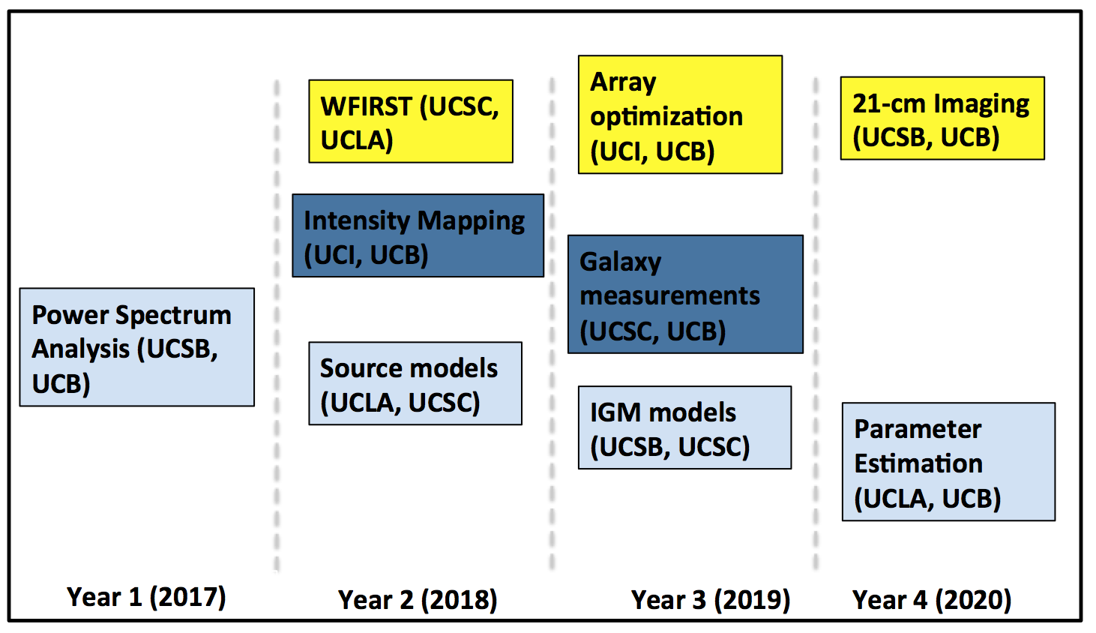

Fig. 3 – **Key Projects within the CDI will connect data to detailed astrophysical models, develop cross correlations between probes, and optimize future endeavors.** The research shown in this chart is color-coded by science theme with key contributors named. For convenience, projects are placed in the year of key deliverables.

***B. Cross-correlations between probes:*** In addition to simultaneous modeling, the cross-correlation of complementary observations, either through statistics or an object-by-object comparison, will provide important windows onto the relation between sources and the IGM, ultimately the key question of the reionization process (Gong et al. 2012, Silva et al. 2013). The CDI collaboration includes experts not only in 21-cm observations but also in galaxy observations, and **we will characterize the insights to be gained by multi-wavelength comparisons.**

(1) *Intensity mapping* describes low-resolution observations of luminous sources, using a spectral line to map them three-dimensionally. It allows the detection of the cumulative emission from (otherwise undetectable) faint galaxies. Crucially, it provides an excellent match to the characteristics of 21-cm surveys, in that both techniques map large volumes of the Universe at low resolution. Co-PI Cooray is a key member of both the SPHEREx and TIME teams, which will perform intensity mapping of distant galaxies in the near-infrared and radio. In collaboration with UCB, Co-PI Cooray will develop optimal algorithms for cross-correlating these probes with HERA data, necessary because both probes are fundamentally statistical.

(2) One obvious question is how 21-cm measurements inform galaxy searches with future facilities like the JWST and the Widefield Infrared Survey Telescope (WFIRST, to launch in 2025). The environments of galaxies are essential for understanding the growth of these early structures as well as the reionization process. Co-PI Robertson will lead the effort to relate galaxy surveys and the 21-cm line, leveraging the 21-cm expertise of UCB. As a leader in both JWST and WFIRST, Robertson is ideally positioned to leverage 21-cm measurements in the galaxy survey community.

***C. Designing future experiments:*** The CDI program will overlap with the primary phase of HERA construction and observations as well as the launch of the next great space observatory, JWST, but it is also during this period that **we must leverage our leadership of this generation of experiments to develop the next generation**, with an ultimate goal of developing our collaboration into an even larger, self-sufficient effort.

(1) As we have already emphasized, these efforts will be most effective in combination with advances in other techniques. Co-PI Robertson will lead an analysis of future galaxy surveys, especially from WFIRST and other near-infrared observatories, in the context of the 21-cm signal and other probes of the Cosmic Dawn. He will develop tools to measure the detailed properties of these galaxy populations from the combination of complementary probes and leverage his role as leader of the Extragalactic Potential Observations Science Investigation Team on WFIRST to ensure that the telescope is optimized for the science of the Cosmic Dawn.

(2) While HERA will make powerful statistical measurements of the 21-cm signal, we ultimately hope to image the IGM structures themselves with high signal-to-noise. This requires both analysis development, to understand the necessary instrument properties, and a more sophisticated theoretical understanding of the IGM structures, which existing models do not accurately describe (Lin et al. 2016; Furlanetto & Oh 2016). Co-PI Oh, with PI Furlanetto, will characterize the ionized “bubbles” that appear in the IGM and their relationship to the galaxy population. ) With UCB, he will also study how these properties can be measured with real interferometers using advanced statistical techniques.

(3) Meanwhile, Co-PI Parsons will lead the team in identifying the key experimental requirements to measure these qualities. UCB will collaborate with Co-PI Cooray to optimize the return from detailed cross-correlations with probes such as intensity mapping.

**III. Organization**

The CDI program requires deep and close collaboration from all the CDI campuses as well as contributions from faculty, postdocs, graduate students, and undergraduates. Each of the science themes will closely involve at least three campuses, with collaborative structures ensuring frequent (see below) communication and joint mentoring, including generous travel budgets, annual meetings, and regular video conferences.

Much of the research described here will be led by junior scientists (both postdocs and graduate students) whose projects link the different campuses, developing a cohort of young investigators skilled in the many fields required by studies of the Cosmic Dawn. Each campus will host a graduate student whose project explicitly links them to a secondary advisor at a different campus. These projects may include the semi-analytic models of galaxy formation (UCLA/UCSC), advanced statistical analysis of IGM structures (UCB/UCSB), and others.

We will also host four postdocs, with at least one assigned to each of our science themes. These positions will be advertised widely, with candidates invited to describe how they will best contribute to these science themes at any one of the CDI campuses while fostering direct collaborations. The successful candidates will be chosen by a panel composed of Co-PIs and Co-Is, with preference given to those with strong scientific records as well as obtaining a wide distribution across the collaboration and across science themes. Two of these postdocs will be funded for three years, while the others will be funded for two-year terms, with a third year to be obtained from extramural sources (see below).

**IV. Summary**

By the end of this decade, the CDI will provide the most incisive constraints on the Cosmic Dawn to date, opening up a crucial epoch of our cosmic evolution that has thus far been relatively unexplored. We will transform the study of the Cosmic Dawn from a largely speculative, theory-driven field to a data-driven science fueled by revolutionary observations from both HERA and improved traditional telescopes, like JWST. The past two years have seen our MRPI planning award help transform the HERA instrument from a prototype to a fully-funded telescope. Leveraging improved observations over the next several years will require substantial scientific investment. The CDI unites five separate research groups from UCLA, UCB, UCI, UCSC, and UCSB into a collaboration of theorists, observers, data analysts, and instrument-builders to construct the detailed interpretive framework that will cement UC’s leadership in all aspects of this field. The UC system is unique in uniting faculty with such a wide-range of expertise in this area, and the MRPI program is the perfect vehicle to develop a cross-campus collaboration devoted to this effort. We will intensively leverage this effort to obtain continued funding for a science institute through private foundations, which have already shown interest in this science (such as the Moore Foundation, which is funding key development for HERA).

The CDI also enables forward thinking about the next generation of instruments (in the 2020s), ensuring UC’s place at the forefront of those experiments. Continuing our team’s leadership of these instruments (including HERA’s successor and Co-PI Robertson’s important role on the WFIRST mission) requires a sophisticated understanding of the science opportunities, to which our wide-ranging expertise is ideally suited. By the conclusion of the MRPI funding, we will become self-sufficient through leadership of the next 21-cm telescope and expanding our vital roles on other instruments (such as SPHEREx and WFIRST).

# Faculty Collaboration and Graduate Student Research Opportunities

The proposed UC Cosmic Dawn Institute (CDI) is an intensive collaboration between UCLA, UCB, UCI, UCSB, and UCSC. As described in the *Proposed Research Activities*, the program will transform UC into the world leader in studying the early history of galaxies in our Universe, the so-called Cosmic Dawn, just as this field enters a mature, data-driven stage. Thanks to the extreme faintness of the signal, the complexity of the statistical analysis, and the huge uncertainties in the underlying science, this effort requires intensive collaboration between instrument teams, observers, data analysts, and theorists.

The CDI team has been carefully constructed to maximize the scientific return of this endeavor by assembling world leaders in each of these aspects. (1) PI Furlanetto (UCLA) is an expert in both theoretical models of the reionization process (the landmark event that ends the Cosmic Dawn) and early galaxy formation. (2) Co-PI Parsons (UCB) is PI of the premier low-frequency instrument for studying this era, the Hydrogen Epoch of Reionization Array (HERA). With Co-I Liu (UCB), he has pioneered the data analysis strategies that will enable extraction of the cosmological signal. (3) Co-PI Robertson (UCSC) is an expert on numerical simulations of early galaxy formation and a key member of the science teams of both the James Webb Space Telescope and the Widefield Infrared Survey Telescope, the next two large NASA missions to study distant galaxy populations. (4) Co-PI Cooray (UCI) is an expert on statistical analysis of cosmological signals and innovative observations of distant galaxies with the SPHEREx and TIME instruments. (5) Co-PI Oh (UCSB) is an expert on models of reionization and the statistics of the theoretical models. While most of our projects will be performed in consultation with the entire team, each of the Co-PIs will lead at least one effort (see Fig. 3).

The CDI will also include a cohort of junior scientists, including four postdoctoral researchers and five graduate students. After international candidate searches, the postdocs will be assigned to our science themes and will, in consultation with the co-PIs, choose a host campus for their work. They will circulate amongst the campuses to provide in-person connections between the research groups. They will also provide leadership in organizing our annual meetings and the closing conference. This collaborative approach will ensure that these scientists are prepared to assume leadership roles in next-generation instruments, such as the successor to HERA.

The graduate students (each partially funded by the CDI) will lead specific projects within the science themes. Because these projects connect two (or more) campuses, each will have a secondary mentor at the collaborating institution and will travel annually to that institution. We note that these collaborations operate across the theory/observation divide so will provide the students with wide-ranging expertise on both models and experiments. In particular, all will work closely with UCB as the complexity of HERA requires close contact between theory and data. This project’s travel budget will be used to facilitate communication within this team, supporting students and postdocs on extended stays at sister campuses as they work together.

Our collaboration will have regular meetings to ensure engagement. We will hold monthly videoconferences, each led by one campus to provide rotating updates on the Institute’s research, education, and outreach components. In addition to travel between campuses, we will host an annual “boot camp” summer conference. The postdocs will provide leadership roles, with the responsibility of educating their peers and other junior scientists on science topics essential to all in the collaboration (such as HERA data analysis, galaxy models, etc.).

The CDI will also foster wider collaborations. In the first year, we will assemble students, postdocs, and faculty for a workshop at UCI to discuss the current state of Cosmic Dawn studies and 21-cm cosmology. This will provide contacts between the core CDI group and interested researchers in related fields. Several of these will be invited to smaller meetings in Years 2 and 3 of the project, in which we will identify fruitful avenues for combining HERA and other 21-cm data with research programs at Keck Observatories and planned with the Thirty Meter Telescope. In Year 4 we will host an international conference, with the aim of summarizing key results.

# Public Engagement and Community Collaboration

While reionization and the Cosmic Dawn are well-known within the astrophysics community, they are just beginning to enter the public consciousness. Over the next decade, interest in the era promises to explode, as the first results from many forthcoming telescopes at multiple wavelengths are reported. The greatest public benefit would be success in observing Cosmic Dawn with HERA, with a full and deep understanding of the astrophysical implications enabled by the analysis and theoretical support of the CDI. We will capitalize on this golden opportunity to communicate the excitement and grandeur of this field to the public. The birth of the first stars and galaxies is an inspiring topic that naturally lends itself to outreach efforts. We will also leverage the exciting new technology of the telescopes with which our team is involved (HERA, JWST, WFIRST), and the publicity they will generate, to extend our reach. We will use two primary platforms: face-to-face contact and our team website.

**Personal outreach** We will exploit the web of existing links the PI/Co-PIs have in their local communities throughout California. This includes local university outreach efforts, talks at local museums and high schools, and ‘pop-up’ events such as Science Cafés and Astronomy on Tap. We will emphasize both annual events, such as UCLA’s annual “Exploring Your Universe” outreach event (which draws more than 6,000 people to campus) and UCB’s annual Cal Day (with similar numbers), and ongoing community outreach, such as UCB’s Astronomy Night (a monthly event drawing more than 100 community members and visitors run by current CDI graduate student Carina Cheng). We will leverage the ongoing engagement opportunities to tell the story of discovery that is central to study of the Cosmic Dawn over the project period. At all of these events, the CDI will ensure a presence with talks, visuals, and demonstrations.

For outreach to be truly scalable, it should involve CDI members at all levels. We will devote time at our summer “boot camps” to train junior researchers (students and postdocs) in the best practices of scientific outreach. They will be briefed on the media tools described below, and we will provide materials to develop popular talks of varying lengths on Cosmic Dawn. We will ‘role-play’ by having them give both popular talks and informal instruction (assisted by media tools) to undergraduates, who will offer critique and feedback. The best talk will be recorded (‘TED’ style) and hosted on our website. We will work intensively throughout the year to find opportunities for students to use these skills “in the field,” including those mentioned above. This emphasis on public outreach will inculcate habits and attitudes that will serve them well throughout their careers.

**Media tools:** To amplify our reach, we will create a multi-media web-based portal for exploration and education. The site will host interactive webpage tutorials on the physics of Cosmic Dawn and observational techniques at varying levels geared toward K-12 students and the general public. These will be developed to dhere with the California Department of Education’s Next Generation Science Standards for California Public Schools. At the high School level, the Cosmic Dawn functions within the HS-ESS1-1 through HS-ESS1-4 standards (part of the Space Systems curriculum), making it easy for teachers at this level to adapt our materials for classroom use. At lower grade levels, the Cosmic Dawn fits less clearly in the curriculum, so we will provide short activities that supplement physical concepts explored within the curriculum, communicating the excitement of frontier science as efficiently as possible.

For the public, we will develop a self-contained web application with which users can model reionization themselves. PI Furlanetto co-led the development of the influential 21cmFAST code (Mesinger et al 2011), which already runs on a netbook. We will pair a stripped-down version of this code with a Python-based GUI so that users can generate their own “maps” of reionization and follow them through observation, analysis, and interpretation. Co-I Oh will develop a set of “fly-through” simulations for download that can be viewed with inexpensive ($2-$15) Google virtual reality glasses and smartphones.

**Evaluation:** We will continually monitor our success in outreach endeavors. At live events, we will distribute questionnaires to participants. We will gather more detailed feedback using the Nominal Group technique and small focus groups at regular intervals, whose effectiveness is understood in the context of astronomy (Hemenway et al. 2013).

# Contributions to Undergraduate Education

The CDI groups have a strong history of engaging undergraduates in the research enterprise, and we will use the cross-campus collaboration to strengthen these efforts. Three of the campuses (UCLA, UCI, and UCSB) will host an undergraduate summer research student twice during the program. (Additionally, UCB is already hosting several undergraduates each summer as part of HERA.) These undergraduates will each be assigned a faculty or postdoc mentor from a collaborating institution, will be invited to the annual collaboration meeting to ensure broad exposure to the field and networking, and will present their work to the full collaboration via a video conference at the conclusion of their summer work period.

Furthermore, we will broaden our impact by incorporating study of the Cosmic Dawn into undergraduate astronomy courses, from introductory general education surveys to cosmology classes aimed at majors. The Cosmic Dawn is a novel field full of energy and new discoveries – but it is so new that its study is barely mentioned in the popular textbooks. We will develop short curricular units that highlight themes common to these courses (such as the importance of telescope technology to astronomy for an introductory course) and make these publicly available for others who wish to incorporate these themes into their own courses. PI Furlanetto (who has experience with textbook development at multiple levels) and Co-PI Parsons (who has a popular physics YouTube series) will lead this development.

# Research Benefits, Impact on UC and California, and Accountability

The CDI is a fundamentally collaborative endeavor that enables unique research opportunities. Astronomy, and in particular the study of the Cosmic Dawn, is now entering an era driven by software and analysis. Optimizing the science return of new observatories – and especially HERA – requires close collaboration between theoretical modelers, data analysts, and the instrument team to achieve **qualitatively new** research that is otherwise impossible. The CDI’s diverse membership assembles these capabilities and will therefore dramatically increase the science return of HERA, JWST, and other future telescopes. We have targeted specific, collaborative research to ensure that UC’s system-wide expertise is utilized most efficiently. We have also developed student/postdoc advising structures that ensure cross-campus collaboration at all levels.

To maximize this efficiency increase, the CDI collaboration will be governed by consensus amongst the co-PIs. The PI (Furlanetto) will coordinate the research and educational activities. We will host monthly tele/video conferences, including both general updates and a rotating focus through our science themes. We will also hold annual in-person meetings, which will serve both as “boot camps” for junior researchers and strategic planning and evaluation meetings for the co-PIs. We will hold a separate teleconference series targeted at our educational efforts (curricular development, public outreach, and coordinating undergraduate research), including junior researchers engaged in these efforts.

The CDI research portfolio will ensure UC’s prominence in one of the frontier fields of astrophysics and cosmology, the study of the first luminous structures in our Universe. It will improve the quality of our student and postdoc population through direct recruitment and indirectly, by providing platforms for students wanting to pursue this area across much of the UC system. Our educational plans, which encompass K-12 students, the interested public, and all levels of students within UC, will ensure that our research is broadly available. Strong engagement with established outreach channels as well as social media platforms will further ensure that our research products and outreach tools are communicated within California and reach as many students as possible.

# Timeframe, Milestones and Evaluation Metrics

The proposed four-year performance period critically enables CDI students, post-doctoral scholars, and faculty to world-leading reionization and cosmology science before and during the operations of the ground-breaking HERA and JWST observatories, and prepare for the implementation phase of WFIRST. At the inaugural conference, the CDI Co-PIs will conduct a planning exercise to review recent advances in the field and, if warranted, adapt the CDI research plan accordingly. The yearly CDI “boot camps” then provide an annual opportunity to assess progress on the benchmarks and milestones, allowing the CDI Co-PIs to create an ongoing, granular evaluation of the program. Important benchmarks will include: 1) the successful deployment of HERA in stages over 2017-19, 2) the recruitment of top quality postdoctoral scholars to the program in years 1 and 2, 3) science papers for each of the major projects identified in Fig. 3, 4) science papers in early 2019 connecting galaxy populations newly discovered by JWST with observations by HERA, 5) the acceptance of CDI undergraduates to astrophysics graduate programs by year 3, 6) the successful placement of CDI graduate students into research positions upon graduation by year 4, and 7) successful funding of a post-HERA 21-cm radio array with UC leadership. For evaluation metrics we will record and report the number and citation rate of refereed publications produced by CDI researchers — we expect at least one refereed publication per postdoc year of CDI funding.

The summary conference in year 4 of the program will allow us to survey the accomplishments by CDI researchers in the broad context of reionization science. At this conference, the CDI Co-PIs will meet to review the development of the field, the productivity of CDI researchers, the impact and success of CDI in reaching the identified benchmarks, and assess the future of the collaboration, including funding.

The CDI will leverage the investment of UCOP funds to generate both research and continued funding from other sources. Correspondingly, we will disclose any JWST, WFIRST, NASA, or NSF-funded research programs incubated from CDI efforts and anticipate the total funding gained through CDI research efforts will exceed the UCOP funding of the Institute. Our primary goals to attain self-sufficient funding are: (1) leadership in the next-generation 21-cm radio array (~2020); (2) a prominent role in WFIRST during its implementation phase (2020-2025); and (3) private or NSF funding of a cross-campus Cosmic Dawn Science Center.

# Literature Cited

Ali, Z. S., Parsons, A. R., Zheng, H. *et al.* 2015, Astrophysical Journal, **809**, 61

Atek, H. *et al*. 2015, Astrophysical Journal **814**, 69

Becker, G. D., Bolton, J., Lidz, A. 2015, Publications of the Astronomical Society of Australia **32**, 45

Bolton, J. *et al*. 2012, Monthly Notices of the Royal Astronomical Society **419**, 2880

Bouwens, R. *et al*. 2015, Astrophysical Journal **811**, 140

Bowman, J. D., Cairns, I., Kaplan, D. L. *et al.* 2013, Publications of the Astronomical Society of Australia **30**, e031

DeBoer, D. R., Parsons, A. R. *et al.* 2016, submitted to Publications of the Astronomical Society of the Pacific (arXiv:1606.07473)

Dillon, J. S., Neben, A. R., Hewitt, J. N. *et al.* 2015, Physical Review D, **91**, 123011

Furlanetto, S. R., Zaldarriaga, M., Hernquist, L. 2004, Astrophysical Journal **613**, 1

Furlanetto, S. R., Oh, S. P., Briggs, F. H. 2006, Physics Reports **433**, 181

Furlanetto, S. R., Oh, S. P. 2016, Monthly Notices of the Royal Astronomical Society **457**, 1813

Gong, Y. *et al.* 2012, Astrophysical Journal **745**, 49

Greig, B., Mesinger, A. 2015, Monthly Notices of the Royal Astronomical Society **449**, 4246

Hemenway, M. K., Finkelstein, K., Redfield, S. 2013, Communicating Science, **473**, 315

Hinshaw, G., Larson, D., Komatsu, E. *et al.* 2013, Astrophysical Journal Supplement **208**, 19

Lin, Y., Oh, S. P. *et al.* 2016, submitted to Monthly Notices of the Royal Astronomical Society (arXiv:1511.01506)

Liu, A., Parsons, A. R., Trott, C. M. 2014a, Physical Review D **90**, 023018

Liu, A., Parsons, A. R., Trott, C. M. 2014b, Physical Review D **90**, 023019

Loeb, A., Furlanetto, S. R. 2013, *The First Galaxies in the Universe* (Princeton Univeristy Press)

Mellema, G., Koopmans, L. V. E., Abdalla, F. A. *et al.* 2013, Experimental Astronomy **36**, 235

Mirocha, J., Furlanetto, S. R., Sun, G. 2016, submitted to Monthly Notices of the Royal Astronomical Society (arXiv:1607.00386)

Morales, M. F., Wyithe, J. S. B. 2010, Annual Reviews of Astronomy and Astrophysics, **48**, 127

Oesch, P.A., Bouwens, R. J., Illingworth, G. D. *et al.* 2014, Astrophysical Journal **786**, 108

Paciga, G., Albert, J. G., Bandura, K. *et al.* 2013, Monthly Notices of the Royal Astronomical Society **433**, 639

Parsons, A. R., Backer, D. C., Foster, G. S. *et al.* 2010, Astronomical Journal **139**, 1468

Parsons, A. R., Pober, J. C., Aguirre, J. E. *et al.* 2012b, Astrophysical Journal **756**, 165

Parsons, A., Pober, J., McQuinn, M. *et al.* 2012a, Astrophysical Journal **753**, 81

Planck Collaboration 2016, submitted to Astronomy & Astrophysics (arXiv:1605.03507)

Pober, J. C., Liu, A., Dillon, J. S. *et al.* 2014, Astrophysical Journal **782**, 66

Pober, J. C., Ali, Z. S., Parsons, A. R. *et al.* 2015, Astrophysical Journal, **809**, 62

Pritchard J. R., Loeb, A. 2012, Reports on Progress in Physics **75**, 086901

Robertson, B. E., Ellis, R. S., Dunlop, J. S. *et al.* 2010, Nature **468**, 49

Robertson, B. E., Ellis, R. S., Dunlop, J. S. *et al.* 2010, Nature **468**, 49

Robertson, B. E., Furlanetto, S. R., Schneider, E. *et al.* 2013, Astrophysical Journal **768**, 71

Robertson, B. E. *et al*. 2015, Astrophysical Journal Letters **802**, 19

Silva, M. B. *et al.* 2013, Astrophysical Journal **763**, 132

Stark, D. P., Ellis, R. S., Chiu, K *et al.* 2010, Monthly Notices of the Royal Astronomical Society **408**, 1628  
Sun, G., Furlanetto, S. R. 2016, Monthly Notices of the Royal Astronomical Society **460**, 417

Tingay, S. J., Goeke, R., Bowman, J. D. *et al.* 2013, Publications of the Astronomical Society of Australia, **30**, e007

Treu, T, Schmidt, K. B., Trenti, M. *et al.* 2013, Astrophysical Journal Letters **755**, L29